ASSIGNMENT-01 SMART HOME AUTOMATION

VIBRATOR MOTOR

BULB

# CONCEPT:

* Here, the led, bulb and the vibrator motor are turned on using the IR remote
* For each element to be turned on different numbers are used on the remote.
* An IR temperature sensor is also used
* It is coded in such away that different elements are operated when the signal is passed from the remote.

# BLOCK DIAGRAM:

INPUT SIGNAL FROM THE IR REMOTE

ARDUINO UNO

LED

**CODE:**

#include <IRremote.h> int RECV_PIN = 5;

int i=0; int j=0; int k=0;

IRrecv irrecv(RECV_PIN); decode_results results; void setup() { Serial.begin(9600); irrecv.enableIRIn(); pinMode(13,OUTPUT);

pinMode(9,OUTPUT); pinMode(11,OUTPUT);

}

void loop() {

//digitalWrite(13,LOW);

if (irrecv.decode(&results)) { Serial.println(results.value, HEX); if(results.value==0xFD30CF)

{

i++;

int x=i%2; digitalWrite(13,x);

}

else if(results.value==0xFD08F7)

{

j++;

int y=j%2; digitalWrite(9,y);

}

else if(results.value==0xFD8877)

{

k++;

int z=k%2; digitalWrite(11,z);

}

irrecv.resume();

}

delay(100);

}

# OUTPUT:

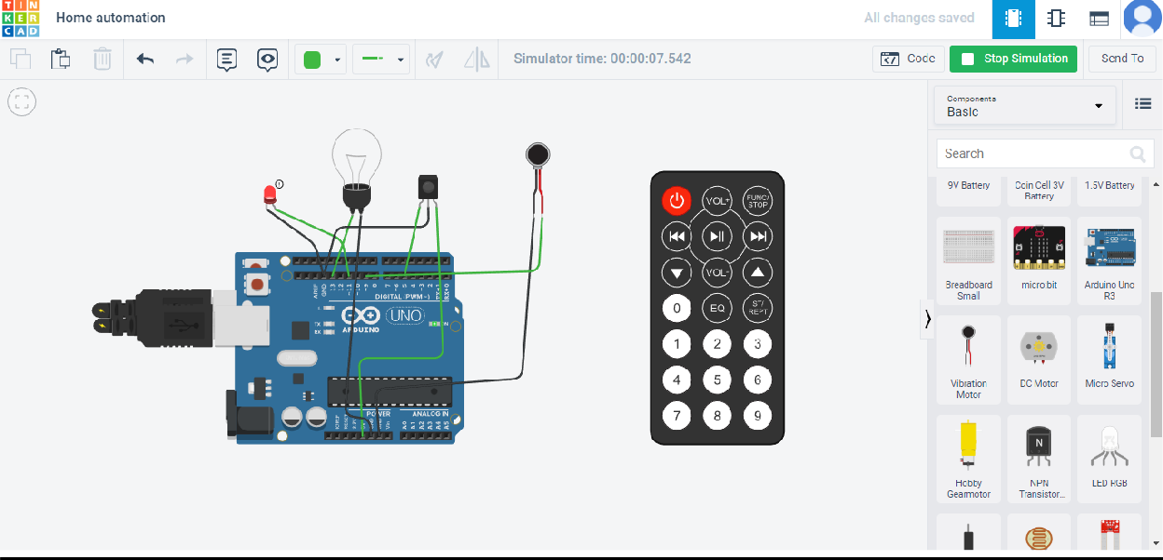

## LED is glown when 2 is pressed in remote

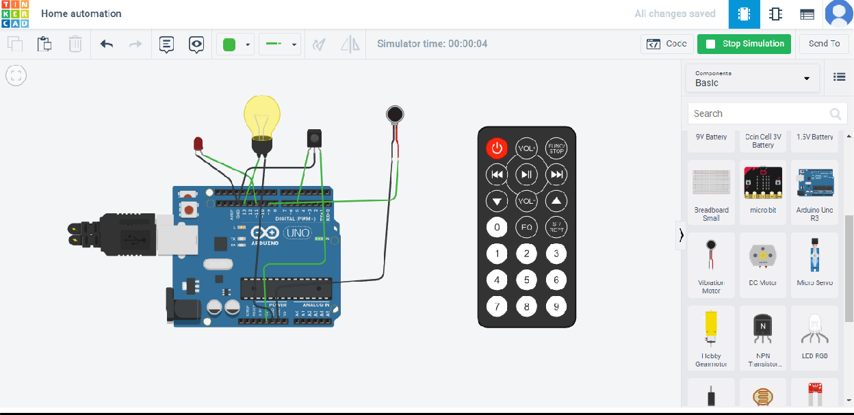

Bulb is blown when 0 is pressed in remote

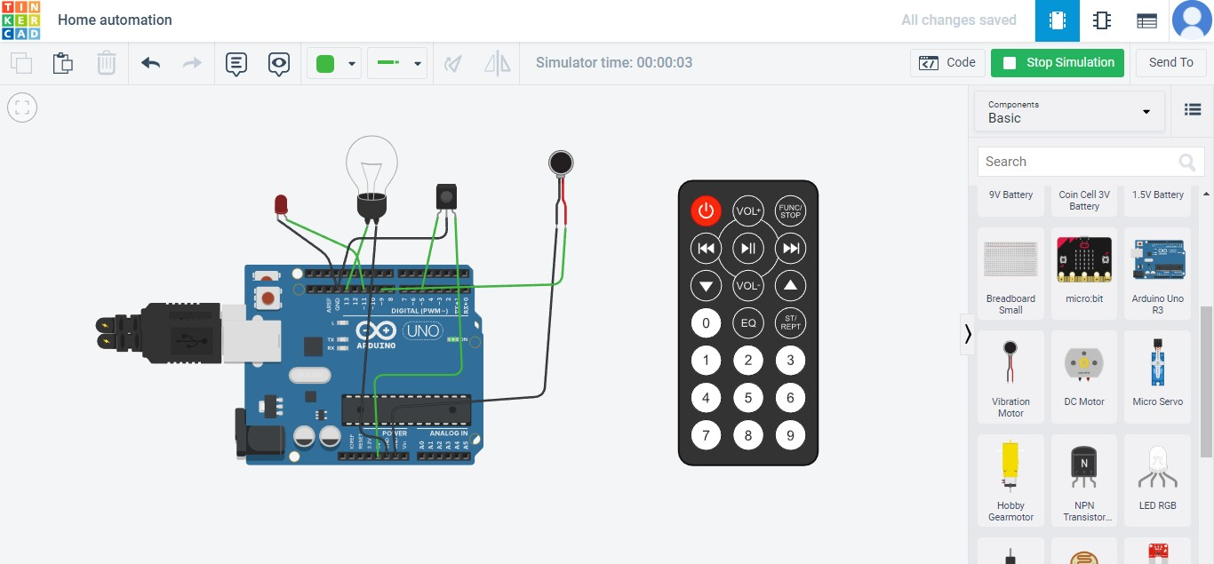

## when no input is given